Assignment 4

Task Description 1:
- Zero-shot: Prompt AI to write a function that checks whether a given year is a leap year.
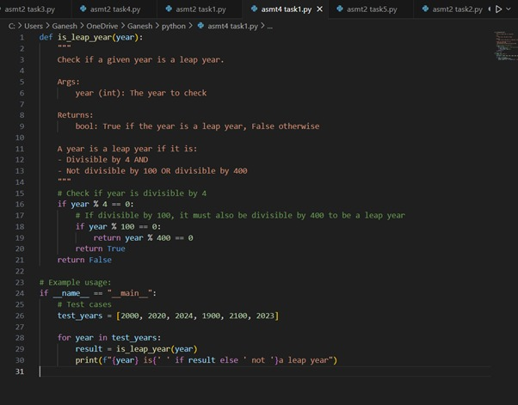

Practical output:
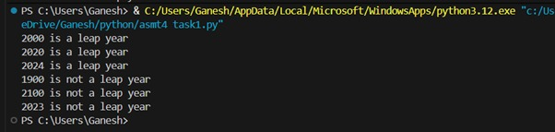

Task Description 2:
- One-shot: Give one input-output example to guide AI in writing a function that
converts centimetres to inches.
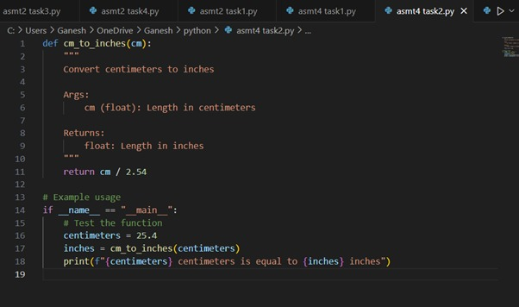

Practical output:

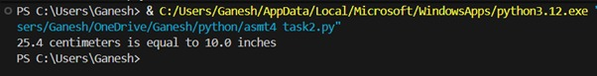

Task Description 3:
- Few-shot: Provide 2–3 examples to generate a function that formats full names as “Last, first”.

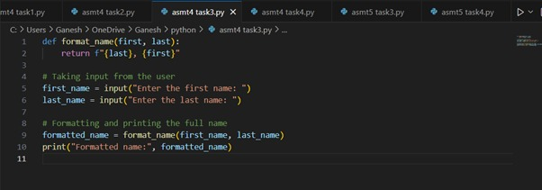

Practical output:

Task Description 4:
- Compare zero-shot and few-shot prompts for writing a function that counts the
number of vowels in a string.

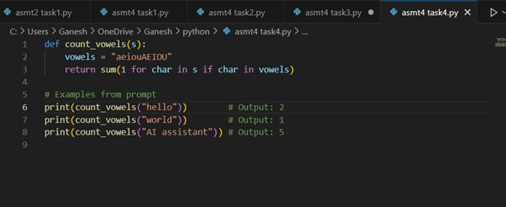

Practical output:

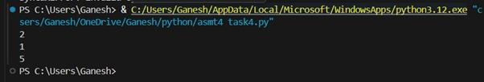

Task Description 5:
- Use few-shot prompting to generate a function that reads a .txt file and returns the number of lines.
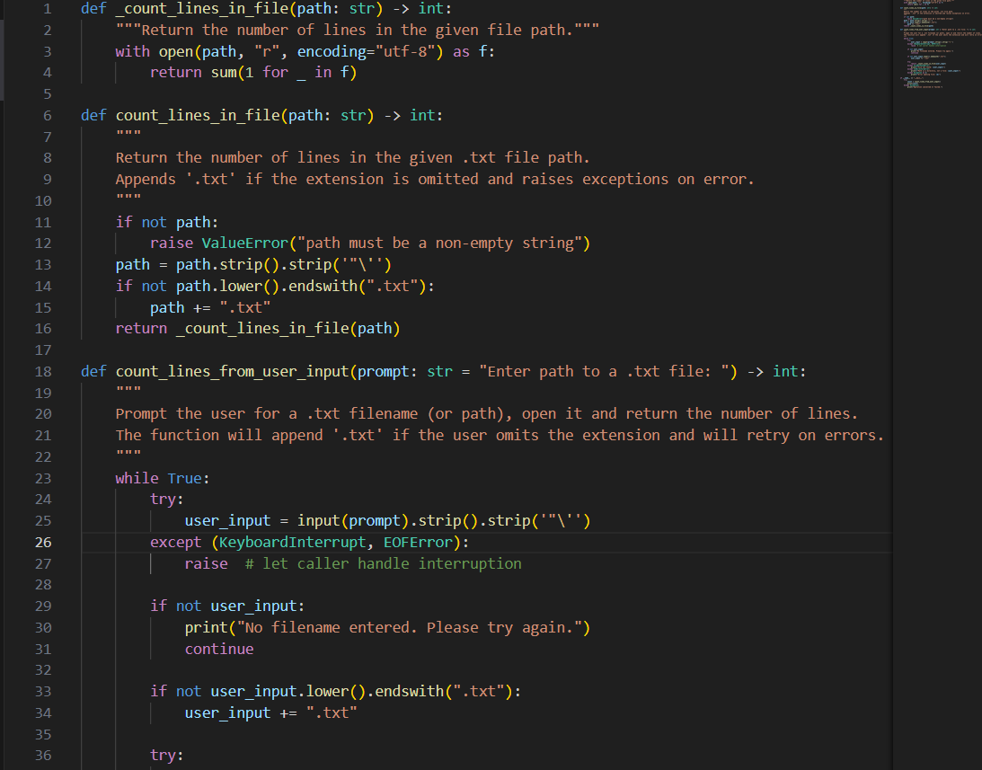
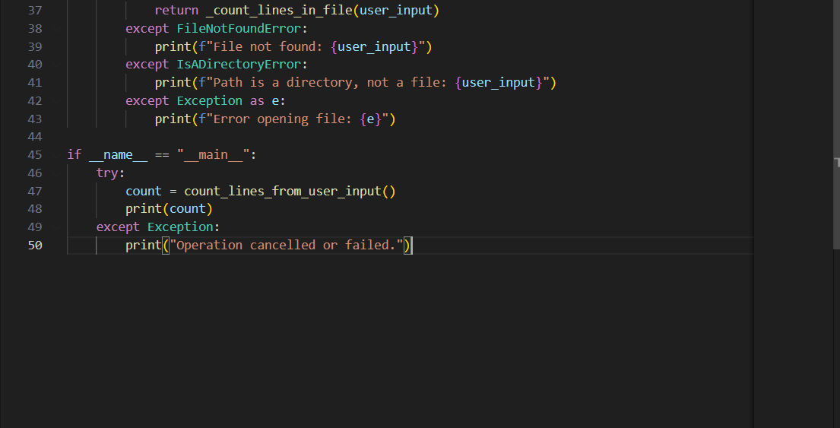

Practical output:

